Elements of Design
Assignment Booklet

Elements of Design

- Designers use various parts or elements in order to make a creation
- All designs incorporate one or more of these elements
- The elements we will focus on are
  - Line
  - Shape
  - Texture
  - Color
Line

Weight

Direction
- There are 4 different lines

Vertical Line

Horizontal Line
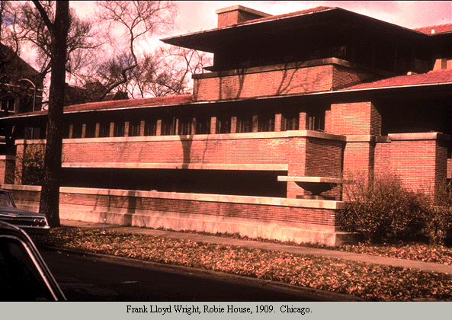

Diagonal Line
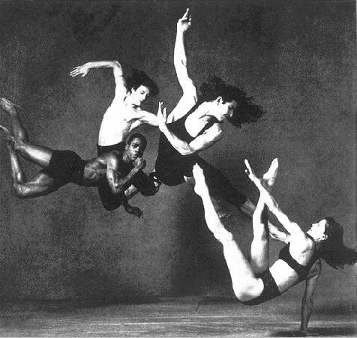

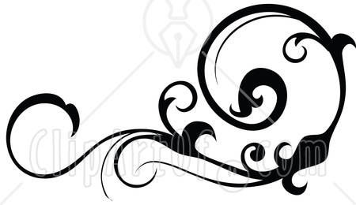

Curved Line

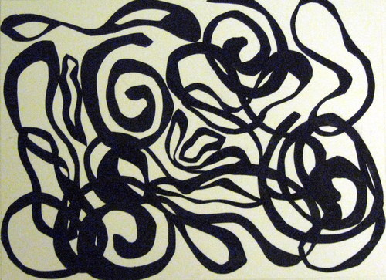

Line Identification Assignment

Your objective in this assignment is to be able to identify the types of lines (Vertical, Horizontal, Diagonal and Curved) in different designs.

This Assignment will be completed in your Power Point Portfolio.

- Begin by setting up an intro slide called Lines in Design.

- Next, set up 4 slides after that each with the title of the different types of lines.

- Once this is set up you will need to search the internet locating 3 examples for each type of line.

- Copy and paste each example onto the appropriate page.

- Organize the examples so they fill up the page.

- Place a yellow line through the design indicating where the Directional Line is.

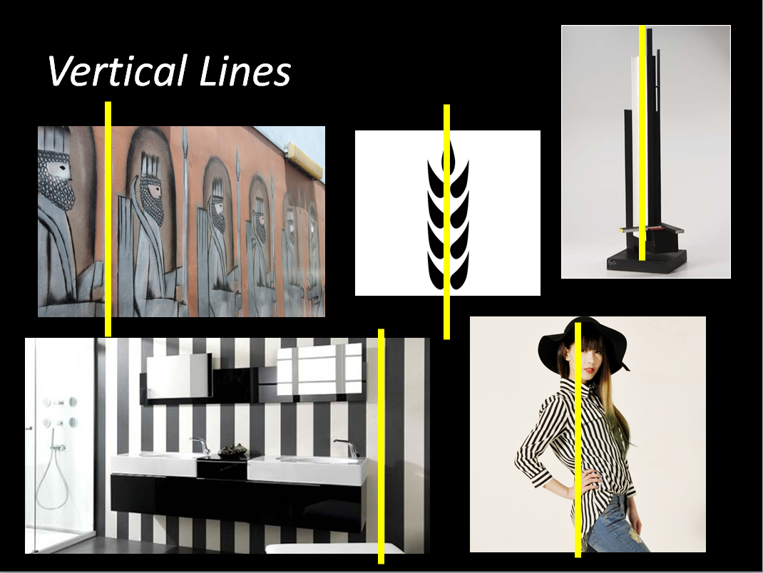

Line Creation Assignment

The purpose of this assignment is to incorporate the lines introduced during class into a design. Below is an example of a created design and a space for you to complete your brainstorming. Your design should include a variety of lines, different styles, and weighting. Remember that different lines and weights will give your design a different feel. Be prepared to explain what type of feeling you are trying to create with your design. After you have completed your brainstorm, please have the teacher initial it. You can then move to the computer and create your brainstormed design on a new page in Inkscape called, “Lines in Design”.
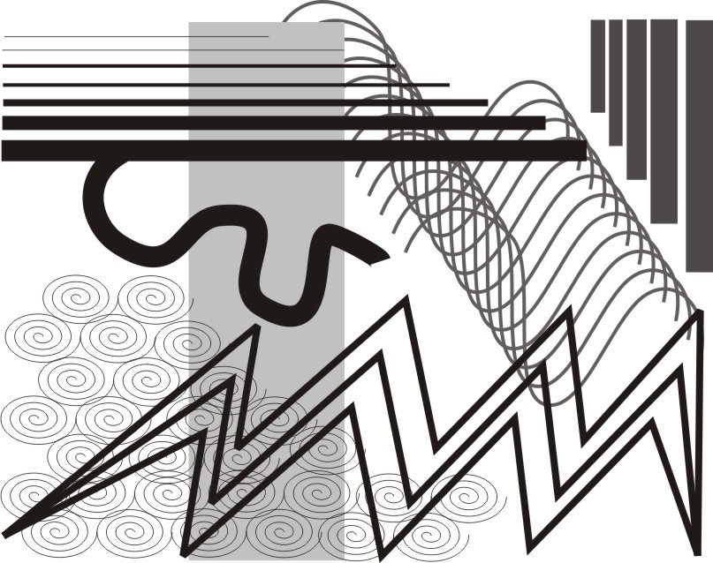

Shape

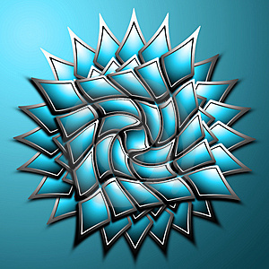

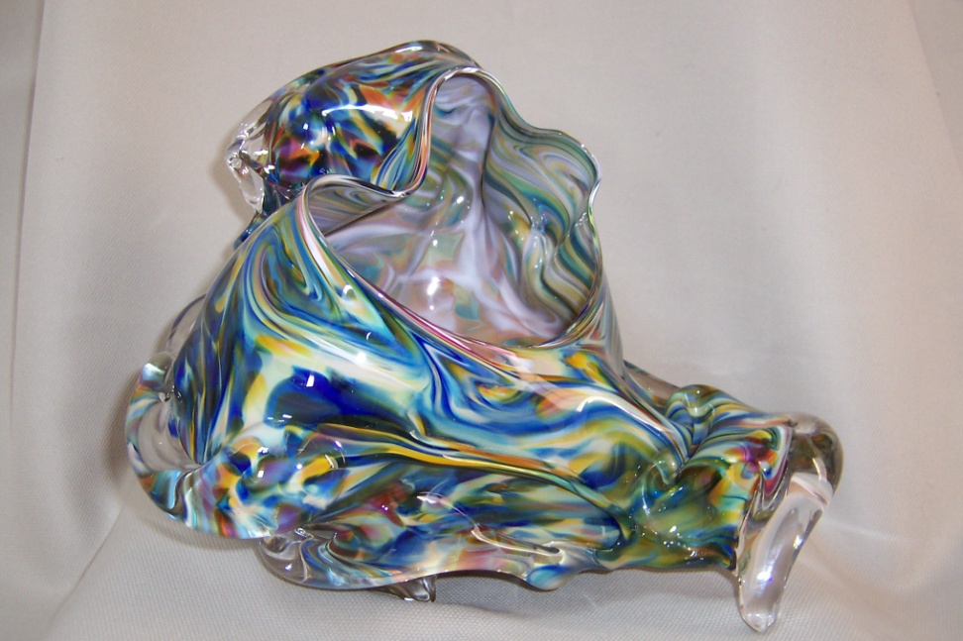

Texture
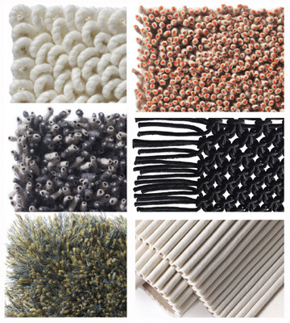

Color
